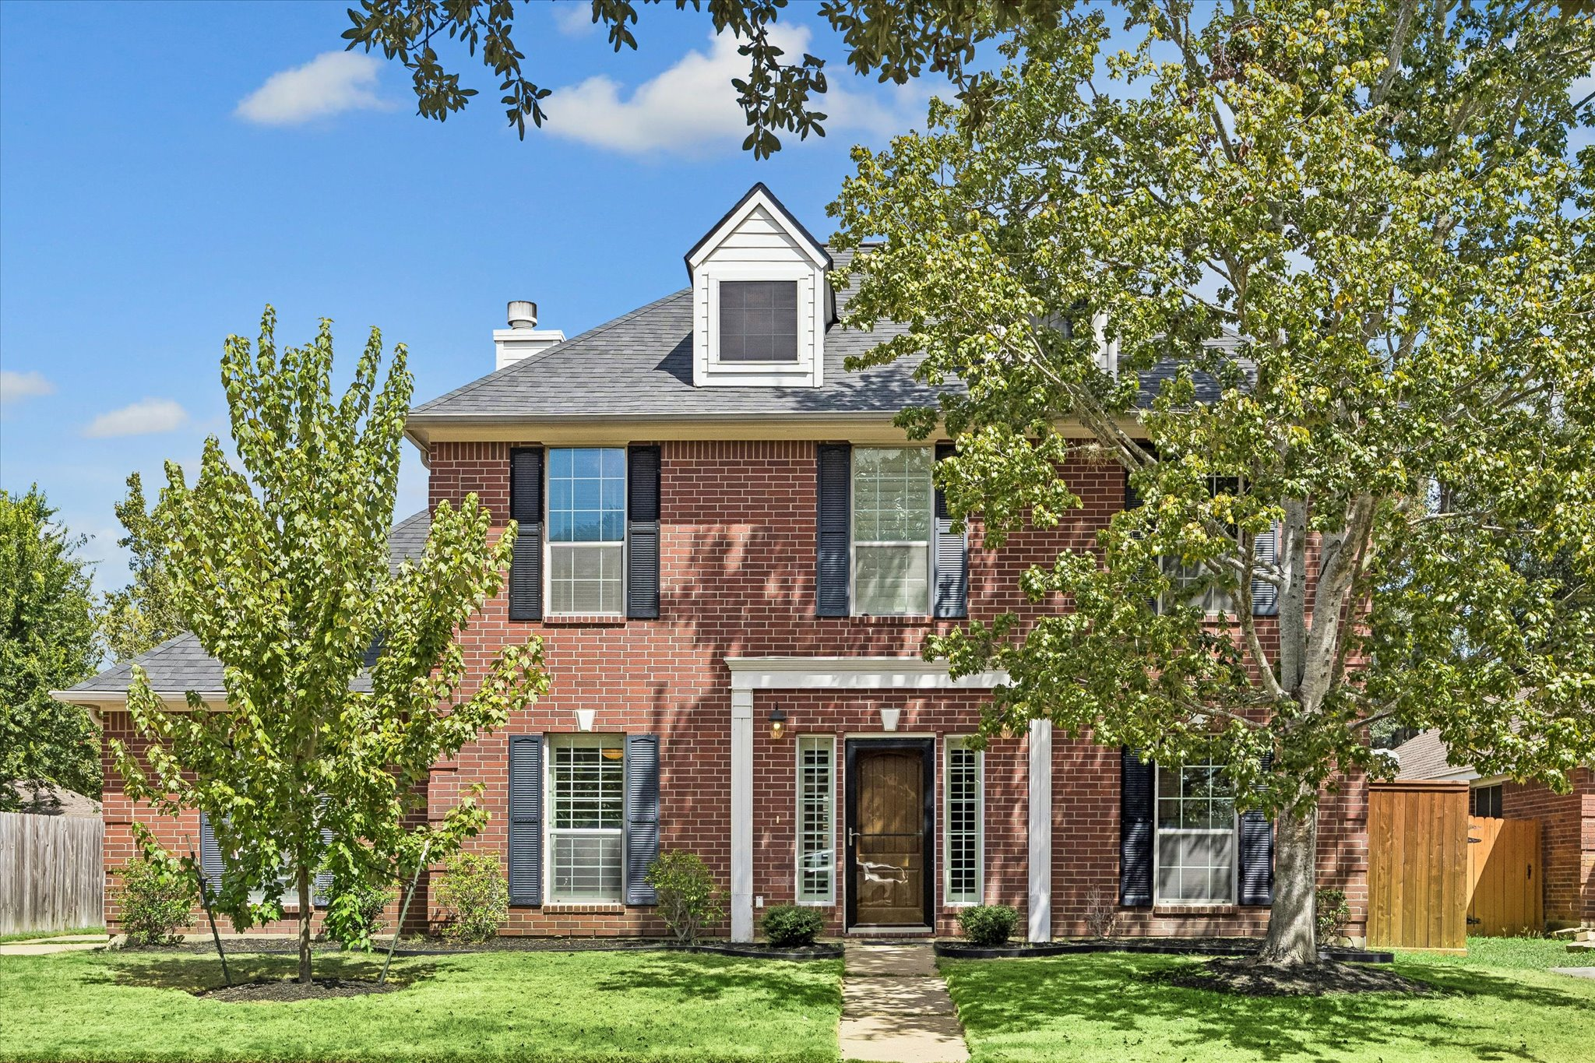

House Overview
—
Bedrooms | 4 bedrooms
Baths | 2 full baths, 1 half bath
Square Feet | 2513, per HCAD
Lot Size | 6825, per HCAD
Year Built | 1991, per HCAD (completely rebuilt in 2003. Only slab foundation is from 1991)
Garage | 2 car detached
Neighborhood | Bear Creek Plantation

OVERALL

- Completely rebuilt from the ground up in 2003 (only the slab is from 1991)
- One of the newest homes in the community, per seller
- New roof on home, breezeway & garage, , Oct 2025 — Atlas Pinnacle Pristine 25-year roof
- New complete HVAC system, April 2023; including 2 exterior condenser units + 2 sets of evaporator coils & plenums in attic
- New duct work, 2023
- Hague WaterMax water treatment system w/ multi-layer charcoal filtration
- Double-pane windows, 2003
- Tankless water heater, 2003
- Continuous soffit vents around home & garage for roof ventilation
- Radiant attic barrier
- Seller reports home consistently performs approx. 30% better in weekly electrical usage compared to similar homes in the area, per Reliant Energy usage reports
- Storm doors at front & back provide added energy conservation & security
- Ceiling fans in every room
- Crown molding throughout
- Plantation shutters throughout first floor
- Zoned to highly rated Cypress-Fairbanks ISD
- MUD Water District 239
- Located in Katy w/ easy access to major highways I-10 and Grand Parkway (99), shopping & dining
- Minutes from Katy Mills, Katy City Park, and George Bush Park
- Bear Creek Plantation community features a clubhouse, playground, park, pool, tennis courts and sand volley
- $506 annual HOA fee

FRONT EXTERIOR

- Open-frame front porch w/ detailed crown molding framing entry door
- Classic brick exterior w/ traditional shutters
- Storm door at front entry
- New Drummond red maple tree, planted June 2024
- Gutters
- Charming curb appeal

BACK EXTERIOR
- Gunite swimming pool with hot tub and water features— approx. 512 SF, per HCAD, built in 2004
- Detached garage — approx. 462 SF, per HCAD
- Breezeway connecting garage to the home, with firewalls on each side of the breezeway
- Storm door at rear entry
- New 6'–8' red cedar fence installed June 2024 — approx. 80 linear feet w/ cap, trim & baseboards, stained on both sides
- Gutters
- Expansive patio space; lots of room for outdoor dining and entertaining

ENTRY
- High ceiling
- Windows with plantation shutter flank the front door
- Wall space for a console and art
- Hardwood floor

DINING ROOM

- Arched opening
- Window with plantation shutters
- Open floorplan with family room
- Ample wall space for art and additional furniture
- Decorative light fixture

KITCHEN

- Black silestone countertops
- Plantation shutters
- GE Profile stainless steel gas range
- GE built-in stainless steel microwave
- Newer Samsung dishwasher, 2023
- Custom cabinetry
- Newer LG refrigerator and freezer drawer, 2016, stays
- Pantry closet
- Island with storage
- Utility closet with newer washer and dryer (which would stay) and storage cabinets
- Ample storage

BREAKFAST AREA

- Located adjacent to kitchen; ideal for everyday meals
- Back door leaded to back patio & pool
- Light-filled room
- Windows with plantation shutters
- Decorative light fixture
- Breakfast table and chairs would stay

FAMILY ROOM

- Spacious room
- Ceiling fan
- Crown molding
- Open floorplan with dining room; ready for entertaining
- Windows with plantation shutters
- Light-filled room
- Fireplace with decorative surround

POWDER ROOM

- Bead board wall
- Pedestal sink
- Located next to the kitchen

PRIMARY SUITE

- Located on the first floor
- Bay window with window blinds
- Ceiling fan
- Crown molding
- Spacious size
- 2 chairs, side table and lamp stay

PRIMARY BATHROOM

- Walk-in oversized shower
- Vanity with silestone countertop, dual sinks, vanity knee space, ample storage
- Large linen closet
- Large walk-in closet

GAME ROOM

- Located on the 2nd floor
- Spacious size
- Makes a perfect space for tv watching and playroom space
- Ceiling fan
- Ceiling speaker
- Windows with blinds
- Crown molding
- Game room couches, chairs and entertainment system, and coffee table stay!

SECONDARY BEDROOM #1

- Located on the 2nd floor
- Window with blinds
- Ceiling fan
- Carpet
- Wall closet
- Crown molding

SECONDARY BEDROOM #2

- Located on the 2nd floor
- Bay windows with blinds
- Ceiling fan
- Engineered hardwood floors
- Closet with sliding glass doors
- Crown molding

SECONDARY BEDROOM #3

- Located on the 2nd floor
- Window w/ blinds
- Ceiling fan w/ light fixture
- Engineered hardwood floors
- Flexible space; makes an ideal study or gym
- Walk-in closet w/ built in hanging & shelving & door access to attic space

SECONDARY BATHROOM

- Located upstairs conveniently with the secondary bedrooms
- Tub/shower combo
- Pedestal sink
- Storage

INCLUSIONS
- Washer and dryer, 2016
- Primary Bedroom 2 chairs, side table and lamp
- Breakfast table and chairs would stay
- Game room couches, chairs and entertainment system, and coffee table
- LG refrigerator and freezer drawer, 2016

