1703 Wyndale Court Floor Plan FF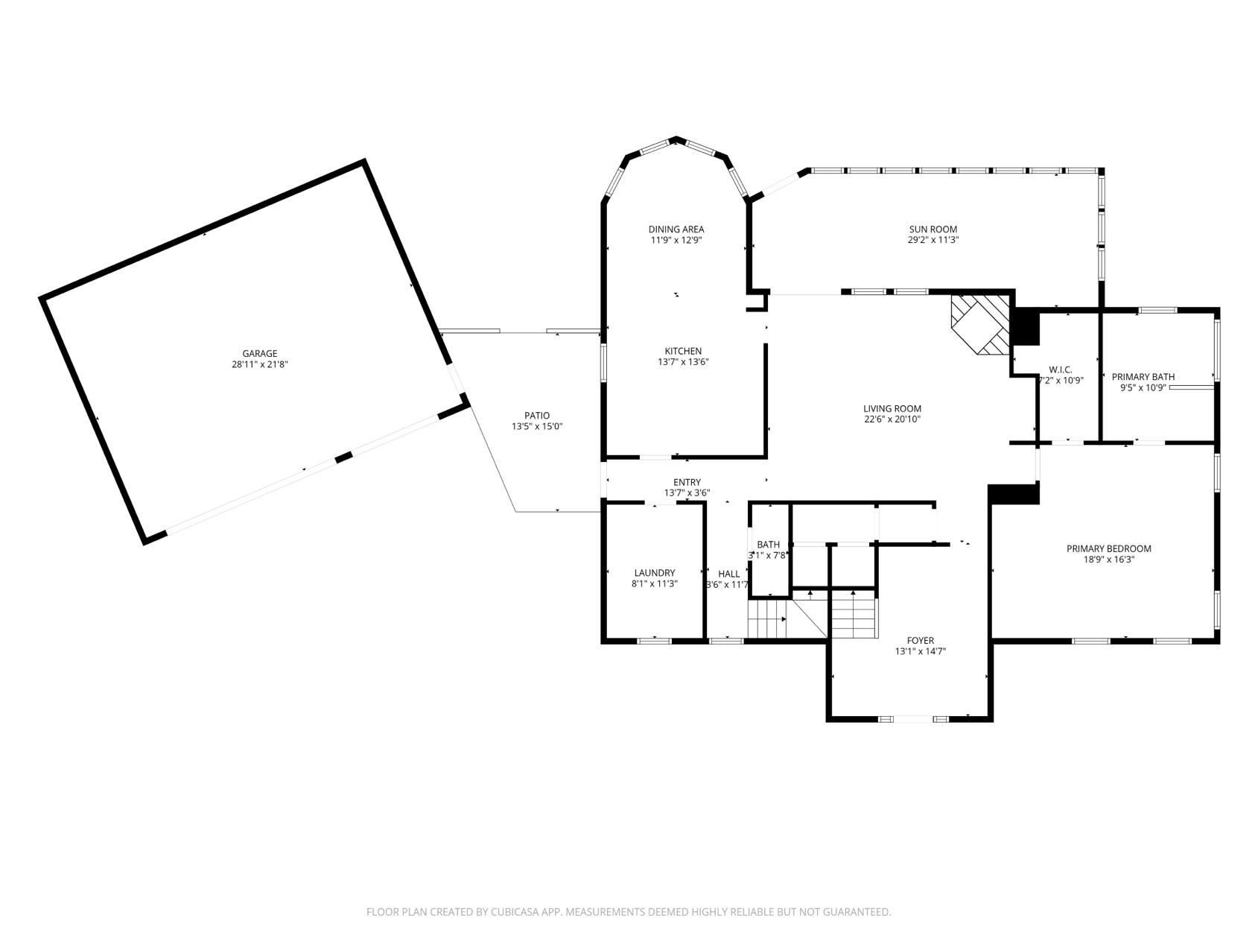
First Floor
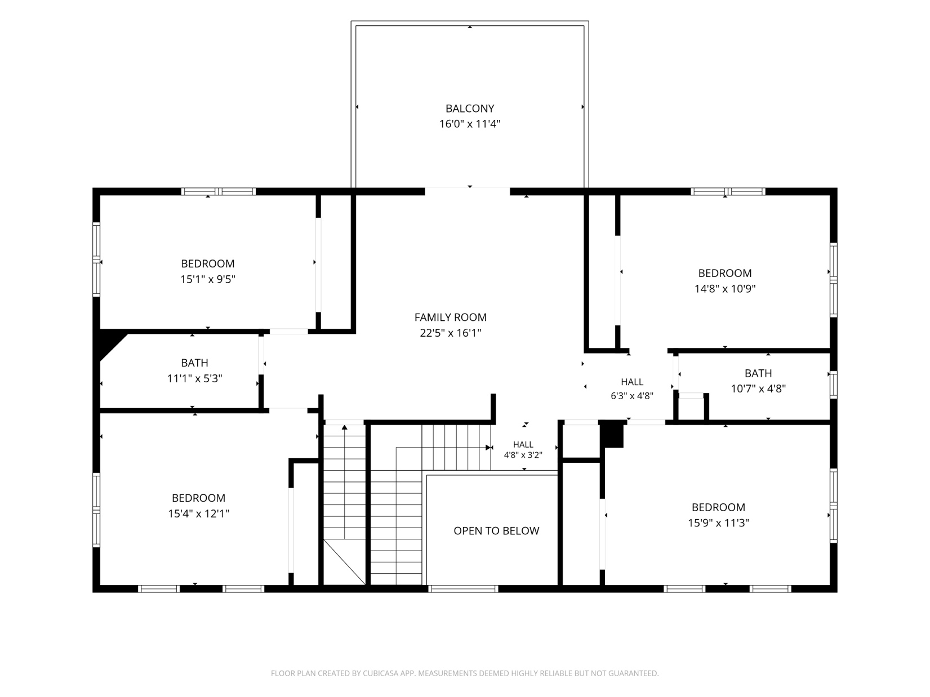

Second Floor

