LAND TITLE SURVEY o· 20' 40' 80'

SET 1/2" I.R. W/CAP MARKED "SUR�Y 1°

RIVERWALK DRIVE
(1oo· R.O. W.)
S 89°47'58" E 205.22'

(A)
FND 5/8" I.R,

J
i--
5'X20' A.E.

SCALE 1"=40'

16' U.E.

--,---1 �- -
- 1-

- -- - - ...lilQ'.. 6.1.... -

9601872

BUILD AREA
1-·
.

WITHIN 50'
7.2
- -----45.4''-' I

FROM 100' B.L. o , ,

96101872
io in
It)

,-- ,----

I{)
-.:t


r--:
0)
(t)


w

I{)
(t)
�
0

0
0
z

METAL BUILDING

ON SI.AB


LOT 5
BLOCK 5

co
(t)
co

0)
(t)


LOT 4

N
0
.N,....
0
0
0
Cl)



FND 5/8" I.R.
(B) N 89°32'48" W

RIVBRWALK
SECTION 4 CABINET Q, SHEET 101
M.R.M.C.

LEGEND

WlIES;
B.L. • | BUILDING LINE
U.E, • | UTILITY EASEMENT
A,E, • | AERIAL EASEMENT
[J | COVERED CONCRETE� AREA
 | -ENCE
99 | 99 |  | 98 CHAIN LINK
II,.,,, | IE  .,,..,, |  | METAL  ,'/ WOOD

  - ALL BEARINGS SHOWN HEREON ARE REFERENCED TD THE SUBDIIIISION PLAT NAMED BELOW, POINTS (A) AND (B) WERE HELD FOR HORIZONTAL CONTROL
  - THIS SIJR�Y WAS COMPLElED \\!THOUT THE BENEFIT OF INFORMATION CONTAINED IN A TITLE REPORT PER THE REQUEST OF THE BUYER.
  - THIS SUR�Y IS CERTIFIED TD BUilT RIGHT HOMES. LLC FOR THIS TRANSACTION ONLY, IT IS NOT TRANSFERABLE TO ADDlllONAL INSTITUTIONS OR SUBSEQUENT OWNERS.
  - ALL EASEMENTS AND BUILDING LINES SHOWN ARE PER THE RECORDED PLAT UNLESS OTHER\\!SE NOlED.
  - THERE ARE NO NATURAL DRAINAGE COURSES ON SUMCT PROPERTY.
LOT 5, IN BLOCK 5, OF RIVERWALK, SECTION 1, AN ADDITION IN MONTGOMERY COUNTY, TEXAS, ACCORDING TO THE MAP OR PLAT THEREOF RECORDED IN CABINET H, SHEETS 157-8 AND 158-A, OF THE MAP RECORDS OF MONTGOMERY COUNTY, TEXAS.

CLIENT:
AUSTIN GARY AND AMANDA CURRY

.J.liurvey}, Inc.

lllU: COMPANY:

G.F. I: 2919929-H09D ISSUE D4lE:
MARCH 5, 2025
www.aurvey1lnc.com FIELD CREW: OATE: 3-8-25
survey 1@s u rv o y 11nc. com 1-....:TR:.:.:.._-1,... ::::.::, ,t;;:io'i 1



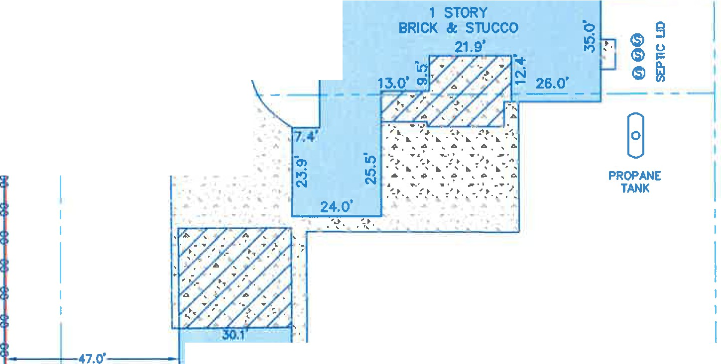
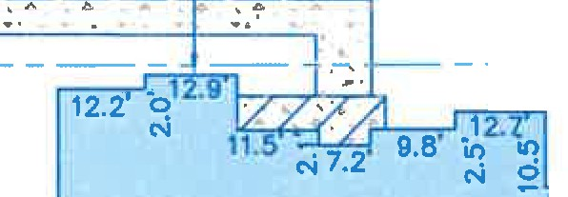
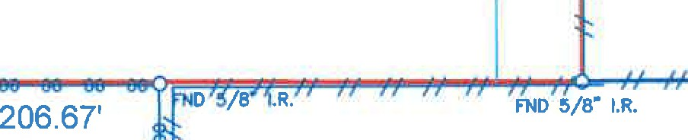

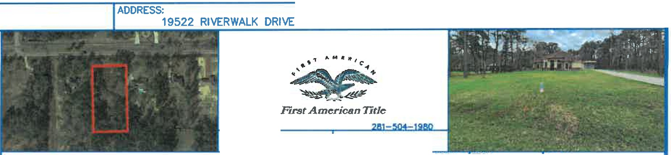
.Land Survey Company
Firm Registration No. 100758-00 DRAFTER· FINAL CHECK: JOB#
P.O. Box 2� I All/In, TX n512 AT. LT 3-148063-25
281 393-1382 I Fo 281 393-13113

