INVESTMENT OPPORTUNITY | THE HEIGHTS, HOUSTON, TX
EXCLUSIVELY LISTED BY TRACY BRANDON, REALTOR
MULTI-BUILDING • MULTI-USE • INNER LOOP
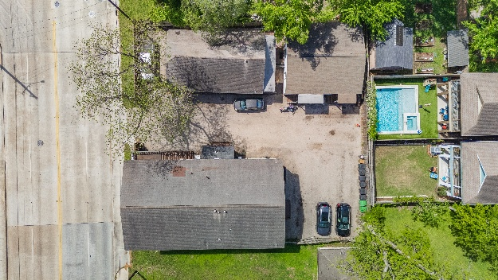
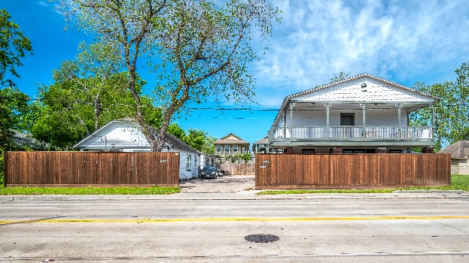
PRIME HEIGHTS INVESTMENT
3-Building Multi-Use Property | 10,000 SF Lot | The Heights, Houston TX
$1,695,000  LIST PRICE | 10,000 SF  LOT SIZE | 3 Buildings  STRUCTURES |  |  | Inside Loop 610  LOCATION | Residential/  Flex  ZONING
PROPERTY OVERVIEW  A rare, one-of-a-kind investment opportunity in the heart of The Heights — Houston's most sought-after inner-loop neighborhood.  This 10,000 SF lot features three structures: a two-story main building and two single-story buildings connected by a covered deck, creating a campus-style layout with exceptional flexibility.  Currently operating as a licensed transitional housing facility, the property carries established use history and demonstrated multi-occupancy capability.  Ideal for investors, developers, nonprofits, and operators seeking a strategic foothold in one of Houston's premier corridors.  Priced to reflect current condition — significant upside potential for the visionary buyer. |  |  | INVESTMENT HIGHLIGHTS  LOCATION PREMIUM  Prime Heights address — strong appreciation history,  supply-constrained inner-loop market  RARE CONFIGURATION  3 separate structures on 10K SF lot — virtually impossible  to replicate in this submarket  USE FLEXIBILITY  Residential zoning with established commercial/group-home  use history — broad buyer appeal  OPERATING ASSET  Active licensed facility — demonstrates permitted use and  immediate income context  CAMPUS LAYOUT  Connected buildings via deck — ideal for group living,  wellness, or co-working  VALUE-ADD UPSIDE  Fair condition pricing creates meaningful spread vs.  renovated comps in the Heights
POTENTIAL USE SCENARIOS
INVESTOR / REDEVELOPMENT | NONPROFIT / FAITH-BASED | GROUP HOME OPERATOR | MULTI-FAMILY CONVERSION | BOUTIQUE COMMERCIAL

TRACY BRANDON  REALTOR | HOUSTON, TX  PHONE: 713-705-6244  EMAIL: Tracy.Brandon@CBRealty.com  WEB: www.coldwellbankerhomes.com/tx/houston/office/heights  BROKERAGE: Coldwell Banker Realty |  |  |  | PROPERTY ADDRESS  1603 Airline  The Heights, Houston, TX  MLS #: 771718  HAR.com | HAR.com/web/tracybrandon/blogs
Information deemed reliable but not guaranteed. All measurements and data should be independently verified. This is not an offer to sell securities.

