chFLATWORK PAVER
B.L. BUILDING LINE
F.L. FRONT LOAD
T.O.F. TOP OF FORM
U.E. UTILITY EASEMENT
U.V.E. UNOBSTRUCTED VISIBILITY EASEMENT M.ACC.E. MAINTENANCE & ACCESS EASEMENT

MANHOLE

PROPERTY LINE BUILDING LINE
EASEMENT
S.I. SWING IN
3C 3 CAR
G.B.L. GARAGE BUILDING LINE (B.G.) BUILDER GUIDELINES
W.L.E. WATER LINE EASEMENT
STM.S.E. STORM SEWER EASEMENT
S.S.E. SANITARY SEWER EASEMENT
R.O.W. RIGHT-OF-WAY
ACC.E. ACCESS EASEMENT
A.E. AERIAL EASEMENT
D.E. DRAINAGE EASEMENT
E.E. ELECTRIC EASEMENT
LIGHT POLE
- ELECTRIC BOX
- FIBER OPTIC
T TELEPHONE PEDESTAL
GRATE DRAIN
PAD MOUNTED TRANSFORMER

WOODEN FENCE
F.F. FINISHED FLOOR EXT. EXTENDED
P.A.E. PERMANENT ACCESS EASEMENT
P.U.E. PUBLIC UTILITY EASEMENT
WATER VALVE FIRE HYDRANT
- GAS METER
C CABLE PEDESTAL

WROUGHT IRON FENCE PROP. PROPOSED
PVT. PRIVATE
I.R. IRON ROD
MONUMENT
W WATER METER
MANHOLE
INLET

OVERHEAD ELECTRIC
C.M. CONTROL MONUMENT
FND. FOUND
I.P. IRON PIPE
P POWER POLE
CO CLEANOUT
& INLET
VAULT

TYPE "A" DRAINAGE

COVERED OUTDOOR
TRI POINTE HOMES ^{LIVING}
TWO STORY
PLAN No. L415 (08-05-2024) ELEV. "F" LEFT
CONC. = 2412 SQ.FT. OPTIONS:
#0486 ALT BATH 2 KITUPGSI
FRESCO501 55" FIREPLACE #0569 STUDY ILO FLEX DEV. MIN FF=274.85
TOP OF. SLAB = 2.6' ABOVE TOC
FINISHED PAD ELEV.=273.85'

PLOT PLAN
SCALE: 1" = 30'
FRONT SOD: REAR SOD: TOTAL SOD:
DRIVEWAY:
IN-TURN: FRONT WALK: PUBLIC WALK: REAR PATIO: A/C PAD:
TOTAL FLATWORK:
FENCE:
LOT COVERAGE:
5153 SQ. FT.
7011 SQ. FT.
12164 SQ. FT.
459 SQ. FT.
306 SQ. FT.
40 SQ. FT.
1103 SQ. FT.
00 SQ. FT.
36 SQ. FT.
1944 SQ. FT.
363.4 LIN. FT.
24.07 %

FOR: TRI POINTE HOMES
ADDRESS: 7082 NORTH LAKE CLOPTON

DRIVE ALLPOINTS JOB#: TP423892 G.F.:
JOB: 3240-0057 FLOOD ZONE:X
COMMUNITY PANEL: 48339C0375G
EFFECTIVE DATE: 08/18/2014 LOMR: DATE:
BY: ELG

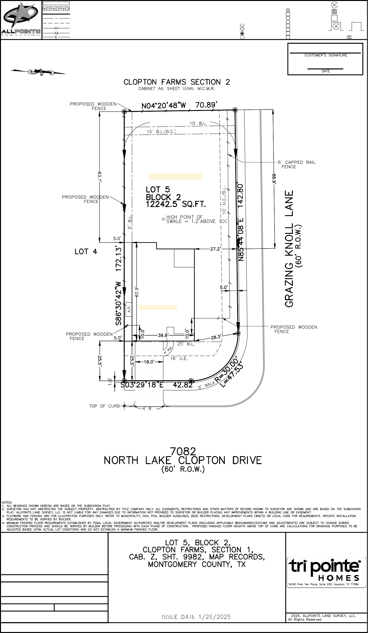

"THIS INFORMATION IS BASED ON GRAPHIC PLOTTING. WE DO ©
NOT ASSUME RESPONSIBILITY FOR EXACT DETERMINATION"
ALLPOINTS LAND SURVEY, LLC. - 1515 WITTE ROAD - HOUSTON, TEXAS 77080 - PHONE: 713-468-7707 - T.B.P.E.L.S. # 10122600

