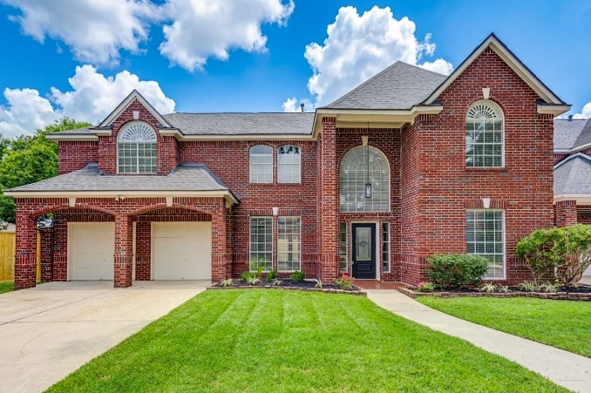
FEATURES & UPGRADES
17318 BONNARD CIRCLE
SPRING, TX 77379
Summary
- New roof
- New Hardi Siding
- Updated kitchen and bathrooms with new granite countertops, flooring, and fixtures
- Fresh interior and exterior paint
- New fixtures and hardware throughout
- New 8ft privacy fence along rear
Kitchen
- New granite countertops and backsplash
- New undermount sink and faucet
- New downdraft cooktop
- New stainless steel double oven
- New LED lighting and updated light fixtures
- New cabinet hardware
Bathrooms
- New granite countertops, sinks, and faucets
- New flooring throughout
- Primary bathroom with new shower tile set on vertical with stunning glass inserts, new shower faucet and frameless glass enclosure
- Jetted tub in primary bathroom
- New mirrors in half bath
- New toilet in bath 3
- New cabinet hardware, faucets, and light fixtures in all baths
Roof, HVAC, Electrical & Plumbing
- New roof
- New Hardi Siding
- HVACs 2022
- New switches and outlets throughout
- GFCI protection added in all wet areas
- New recessed LED lighting, ceiling fans, and updated fixtures throughout
- New sinks, faucets, and plumbing supply lines
Flooring & Hardware
- Beautiful new LVP flooring downstairs
- New tile flooring in all upstairs bathrooms
- New carpet and padding
- New door hardware, door stops, towel bars, cabinet pulls, and bathroom mirrors
Exterior
- Flagstone rear patio deck
- Gutters added at back
- New 8ft privacy fence along back of property
- New sod installed in front and back yard
- New exterior light fixtures
Additional Highlights
- All major systems professionally serviced and cleaned
- Home professionally cleaned and move-in ready
Location
- Located in an established, family-friendly neighborhood
- Beautiful subdivision with mature trees
- Convenient access to major thoroughfares
- Close to schools, shopping, restaurants, and medical facilities
- Zoned to highly regarded Klein Independent School District

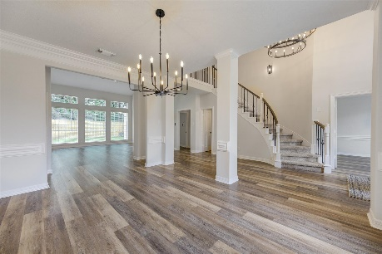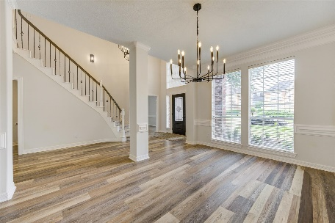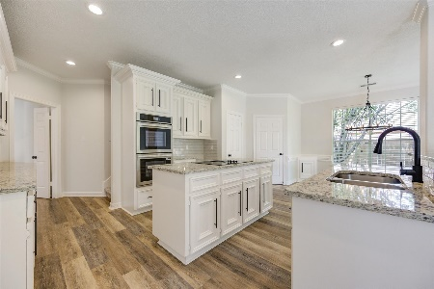
OPEN-CONCEPT FLOOR PLAN SPACIOUS & BEAUTIFUL KITCHEN

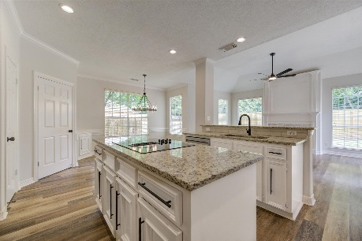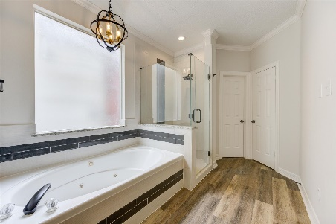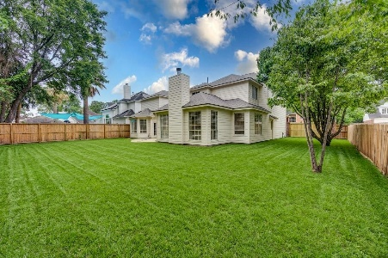
KITCHEN PRIMARY BATH TUB & SHOWER SPACIOUS BACKYARD

