Information herein must be verified by interested parties. Bentwater website: https://www.bentwater.com/
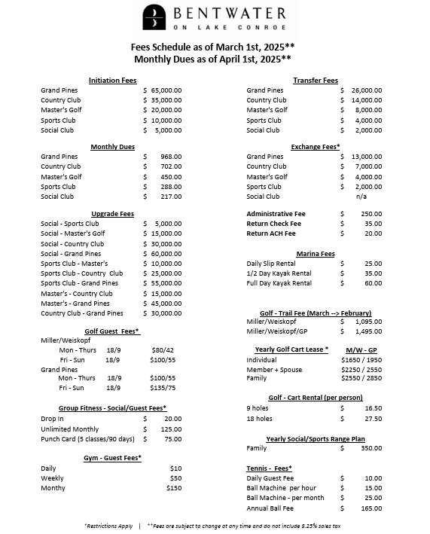

Set along 12.5 miles of Lake Conroe shoreline, Bentwater is a 1,400-acre master planned community nestled between the 22,000-acre Lake Conroe and the 160,000-acre Sam Houston National Forest. Residents and guests enjoy a resort-style lifestyle with 54 holes of championship golf, a 10,000-square-foot fitness center, salon & spa, racquet club, marina, 44 guest villas, and the private Grand Pines Golf Club.
Bentwater also stands as Lake Conroe's premier waterfront destination for golf, meetings, weddings and special events. Resort-style amenities, overnight accommodations, and convenient access to Houston and The Woodlands make Bentwater the perfect destination for your next golf outing or special event.
Bentwater is the only private, gated, waterfront community in Texas to offer 54 holes of championship golf—an unmatched opportunity to experience variety, challenge, and scenic beauty all within one extraordinary setting.
Designed by nationally recognized architects Tom Weiskopf, Jay Morrish, Jeffrey D. Blume, and Scott Miller, each course delivers distinctive character and thoughtful design set against stunning natural surroundings.
All three courses are anchored by the stately Bentwater Country Club, featuring a full-service team of golf professionals, well-appointed golf shops, exceptional dining venues, and beautifully maintained locker rooms—ensuring a complete and elevated club experience from the first tee to the final putt
Centrally located within the community and adjacent to the main Clubhouse, the Bentwater Sports Club is much more than just a fitness club. Fully staffed with an array of Personal Trainers, Group Fitness Instructors, Tennis & Pickleball Professionals, Golf Academy Pros, Swim Instructors, Day Spa and Salon Technicians, the Sports Club offers a variety of health and wellness programming for each member of your family.
Elevate Your Fitness at Bentwater Sports Club
With over 10,000 square feet dedicated to health and wellness, the Fitness Center at Bentwater Sports Club is your ultimate destination for strength, energy, and community. From personal training and group fitness classes to yoga, Pilates, and sport-specific programs, we have everything you need to stay healthy, strong, and motivated.
Our cutting-edge facility features resistance machines, free weights, circuit-training equipment, and a full cardio area with treadmills, ellipticals, bikes, and a cardio theater to keep workouts engaging. Certified trainers are available seven days a week to guide you, demonstrate proper equipment use, and design personalized programs tailored to your goals—whether it’s weight loss, rehabilitation, strength building, or improving overall fitness.
The Group Fitness studio offers over 30 classes weekly, from high-energy Zumba and Chisel to calming Yoga and Pilates—all led by professional instructors.

After your workout, relax in our fully equipped Men’s and Ladies’ Locker Rooms or enjoy the Sports Club Pool, featuring a 25-meter junior Olympic pool, Jacuzzi, children’s wading pool, and a sun-soaked lounge area.
At Bentwater Sports Club, fitness, fun, and community come together to support your healthy lifestyle.
Call (936) 597-2260 or email info@bentwaterclub.com to learn more.

