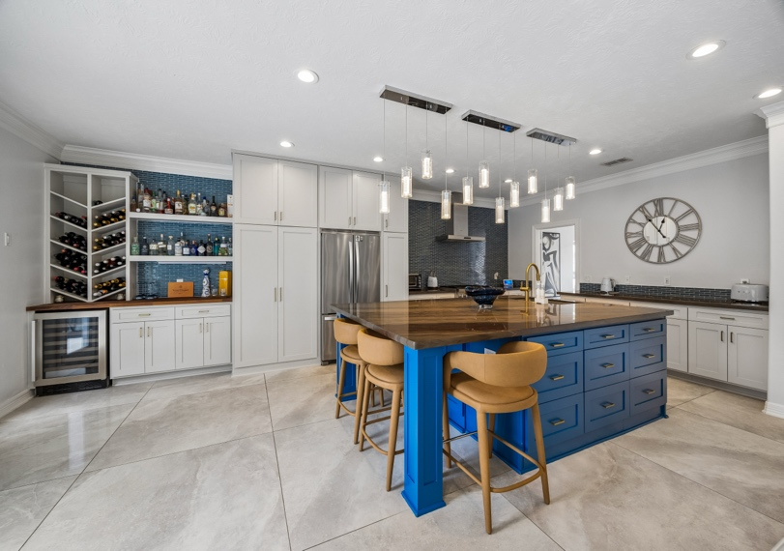 | 2011 Opal Springs  Lakes of Buckingham | Katy, TX  A true top-to-bottom transformation, blending luxury finishes, modern design, and meaningful updates that make the home feel like new.  5 BEDS | 3.1 BATHS | POOL/SPA
A fully updated Kelliwood residence offering timeless curb appeal, refined interiors, and resort-style outdoor living in one of Katy’s most sought-after gated communities.
- Located in the prestigious, 24-hour manned gated community of Lakes of Buckingham in Kelliwood  - Fully updated inside and out  - 5 bedrooms  - 3.5 bathrooms  - Oversized 2-car detached garage | - Built in 2003  - Approximately 3,400 square feet  - Situated on an 8,600+ square foot cul-de-sac lot  - Zoned to top-rated Katy ISD schools

Designer Renovation & Major Recent Upgrades Updates:
A true top-to-bottom transformation, blending luxury finishes, modern design, and meaningful updates that make the home feel like new.
- Fully reimagined, taken-to-the-studs kitchen renovation featuring high-end finishes and an open, modern layout  - Completely redesigned primary bathroom with a full down-to-the-studs renovation  - Remodeled powder bathroom and all secondary bathrooms with updated finishes  - Updated flooring throughout the entire home, with no carpet anywhere:  - Wood flooring on the staircase and throughout all upstairs hallways and bedrooms  - Herringbone-pattern wood flooring in the primary bedroom  - Polished 4’ x 4’ marble-look tile flowing from the entry throughout all main living areas downstairs  - Fireplace upgraded with a new biofuel fire feature and custom wood paneling | - Modern, on-trend tile flooring in all bathrooms  - Updated, high-end lighting throughout the home  - Front entry enhanced with a newly installed wrought iron double front door  - Staircase updated with iron spindles  - Recently resurfaced pool with updated tile and coping  - Covered outdoor kitchen, fully equipped for entertaining  - All new window shades, including motorized shades throughout the downstairs  - Roof replaced in 2018  - Downstairs HVAC system replaced in 2017  - Pentair Clean & Clear® Plus cartridge filters replaced in 2024
Showpiece Kitchen & Fully Renovated Bathrooms:
From statement-making design details to everyday functionality, these spaces were thoughtfully transformed from top to bottom, where bold design, thoughtful function, and high-end finishes come together in the spaces buyers care about most.
- Fully remodeled kitchen, taken down to the studs and thoughtfully redesigned to create a modern, open-concept layout  - Custom kitchen features include:  - All new cabinetry  - A massive, vibrant blue central island with extensive pull-out drawer storage, accented by gold hardware and a series of stylish pendant lights  - Rich, polished brown quartz countertops  - Designer glass mosaic tile backsplash  - Stainless steel Thermador range and vent hood  - Floor-to-ceiling cabinetry surrounding the refrigerator for a built-in look  - Butler’s pantry area complete with butcher block countertops, built-ins, and a wine cooler  - Built-in serving area that seamlessly connects to the formal dining room | - All bathrooms throughout the home have been completely updated  - Primary bathroom fully taken to the studs and reimagined with:  - Textured, floor-to-ceiling tile walls  - Seamless walk-in shower  - Modern freestanding soaking tub  - Floor-to-ceiling penny tile in the water closet  - Dual sinks with updated cabinetry and countertops  - All new modern fixtures  - Secondary bathrooms both fully updated with:  - Updated vanities  - Modern tile flooring  - On-trend tile surrounding the tub  - Framed mirrors  - All new lighting and fixtures

Versatile Layout & Elevated Interior Details:
From flexible living spaces to standout architectural touches, this home blends everyday function with custom-feeling design.

- Welcoming two-story entryway anchored by a grand staircase with wood steps  - Versatile formal living room or home office  - Formal dining room featuring a new chandelier and floor-to-ceiling windows  - Spacious living room with modern wall paneling and wall-to-wall windows overlooking the private backyard oasis  - Versatile game room or media room with dual pocket doors, wood flooring, and a ceiling-mounted projector | - Private primary suite complete with:  - Herringbone-pattern wood flooring  - Built-in bench seat  - Coffered ceilings with crown molding  - Bold wallpaper accent wall  - Walk-in closet with extensive built-ins lining the entire space  - Four spacious secondary bedrooms with wood flooring  - Gigantic laundry room

Resort-Style Backyard & Outdoor Living Designed to Impress
With expansive entertaining space, a resurfaced pool, and a fully equipped outdoor kitchen, the backyard delivers on both function and wow factor.
- Massive covered outdoor kitchen complete with:  - Granite counters  - Cedar-stained ceilings  - Stainless steel grill and vent hood  - Char-Broil digital electric smoker  - Wine fridge  - Sink  - Built-in speakers | - Recently resurfaced pool with updated tile, coping, and stamped concrete surround  - Lush landscaping and green space  - Modern gas firepit  - Gigantic garage with ample storage and direct backyard access

Perfectly Located & Award-Winning Schools
Offers a rare blend of resort-style living, established charm, unbeatable everyday convenience, and top-rated schools.
- Located in the prestigious Lakes of Buckingham Kelliwood with 24/7 manned security, scenic lakes, pool, tennis courts, beach volleyball court, and playground.  - Convenient access to I10, the Westpark Tollway, 99 (Grand Pkwy), and endless shopping and dining options. | - Zoned to highly sought-after, award-winning Katy ISD schools, including:  - Hayes Elementary School: The ninth-best elementary school in Harris County and ranked in the top 25 in the greater Houston area.  - McMeans Junior High: #2 in the greater Houston area and #25 in Texas.  - Taylor High School: A top 25 public school in the greater Houston area.
