17210 Newtonmore Crossing Dr
Upgrades made by Seller to Property
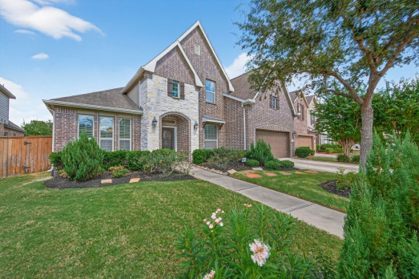
2016 - Custom pool & outdoor kitchen and landscaping - $82,000
2016 – Rain gutters added to home - $1,000
2016 – Picture Frame windows
2016 - Kinetico Water Softener
2016 - Theatre Room electronics - $10,000
- Epson PowerLite Pro Cinema 4030
- Projector / 3 LCD / 2000 Lumens True 3D Projector / 1920X1080 / Up to 120,000:1 Contrast Ratio
- 2 PAIR Of Glasses / Spare Lamp
- Screen Innovations 92" Slate Zero Edge HD Theater Reference Projector Screen / 5TZ92SL12L / Total Width 80.9”
- Onkyo AV receiver
- 6 speakers, 2 front 2 rear, 1 center and 1 sub
- BluRay Player
2019 – Ecobee Stats – whole house $600

2021 – Upgraded pool decking to travertine $25,000
2022 – Foam insulation in front attic - $2500
2022 – Landscaping - $5,200
2025 –AprilAire whole home dehumidifier installed $4100
Comfort & Energy saving features throughout home provided by Builder
- Anti-scald valves to prevent accidental burning in showers and tubs
- R-22 insulation in non-flat ceiling areas
- R-38 insulation in air conditioned flat ceilings
- Radiant barrier roof decking in attic
- Energy Star rated ceiling fans
- Built to meet stringent Environments for Living TM Platinum Level energy efficient program

