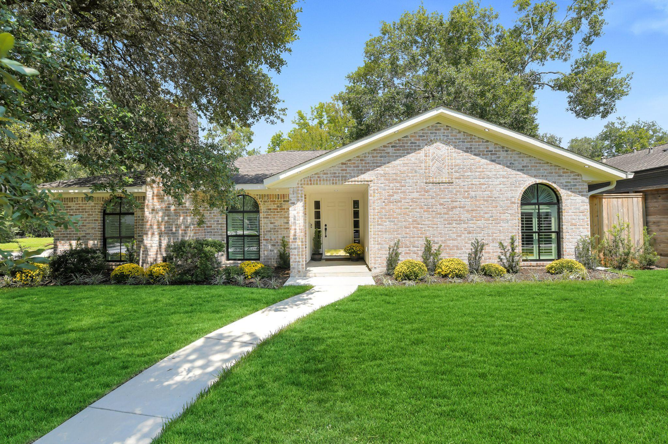

House Overview
—
Bedrooms | 3
Baths | 2 Full
Square Feet | 2385 per Appraisal
Lot Size | 9840 per HCAD
Year Built | 1963 per HCAD
Garage | 2 Car Attached
Neighborhood | Walnut Bend

OVERALL
- Corner lot
- Located in the heart of desirable Walnut Bend
- Large front yard with walkway leading to the front porch
- PEX interior plumbing lines
- All new flooring, 2019
- Interior painted, 2019
- Exterior redone with all new brick, 2023
- Roof age approx 8-10 years old
- HVAC, 2019
- Water heater, 2021
- Electrical updated, 2019
- New sewer lines, 2023
- Updated windows
- NO carpet
- New driveway located on the side of the home redone in 2023
- Walnut Bend Home Association
- Neighborhood amenities include: tennis & pickleball courts, park, playground, swimming pool, & splash pad
- Minutes from tons of popular dining & shopping at CityCentre, Town & Country Village, Memorial City Mall
- Easy access to major freeways Beltway 8, I10, Energy Corridor

FRONT EXTERIOR

- Charming curb appeal
- Private double-wide driveway located on the side of the home, redone in 2023
- Exterior redone with all new brick, 2023
- 2 car attached garage with automatic garage door opener
- Walkway leading to the front door and covered front porch
- Front green space
- Mature trees
- Recently landscaped
- Sprinkler system

BACK EXTERIOR
- New patio, 2023, offers plenty of room for outdoor furniture and grilling
- Expansive greenspace; lots of room for kids/pets to play
- Exterior redone with all new brick, 2023
- Fully fenced
- Sprinklers installed
- Gutters
- Access from dining room
- Access from garage

ENTRY
- Spacious front entrance offering tons of room for console table/artwork
- Decorative light fixture
- Wooden entry door
LIVING ROOM
- Oversized room allows for multiple sitting areas/large furnishings
- Gas fireplace with bricked surround and wood mantle
- Floor plan flows into dining/family room area with kitchen; ideal for entertaining and everyday living
- Recessed can lights
- Oversized window with window blinds; allows for abundant natural sunlight
- Two windows with arched plantation shutters

DINING ROOM
- Conveniently located adjacent to the kitchen & flex space; open floor plan ideal for entertaining and everyday living
- Flexible room; could also make an ideal family room/sitting area
- Room for a large dining table and additional furniture such as a buffet
- Recessed can lighting
KITCHEN
- Light and bright kitchen
- Completely redone with all new cabinets
- Quartz countertops
- Pantry closet
- New cabinetry
- Ample storage
- 5 burner gas stainless steel LG range
- Stainless steel dishwasher
- Built-in stainless steel LG microwave
- Stainless steel
- Oversized one basin stainless steel sink
- Under cabinet lighting
- Recessed can lighting

FAMILY ROOM
- Oversized window floods the room with natural light
- Recessed can lighting
- Flexible space; could make an ideal dining nook
- Expansive adjacent hallway area allows for additional furniture such as a buffet or could make a great playspace for kids

PRIMARY SUITE
- Ceiling fan/light fixture
- Built-in vanity area with quartz countertop situated between the closet and primary bathroom
- Expansive room
- Window with window blinds
PRIMARY BATHROOM
- Large vanity with undermount sink
- Decorative hex tile floor
- Vanity light
- Ample storage
- Tub/shower combo with white subway tile wall
- Privacy window
- Walk-in closet with built-in storage

SECONDARY BEDROOM #1
- Located to the right of the foyer
- Closet
- Window with plantation shutters
- Ceiling fan/light

SECONDARY BATHROOM
- Located conveniently between the two secondary bedrooms
- Also located adjacent to the dining/kitchen area
- Expansive counter with quartz countertop and undermount sink
- Ample storage space with soft close
- Tub/shower combo with white subway tile wall
- Vanity light fixture
- Privacy window
- Decorative hex tile floor

SECONDARY BEDROOM #2
- Window with window blinds
- Closet
- Ceiling fan with light
BONUS ROOM
- Adjacent to attached garage
- Flexible space: makes an ideal mudroom or home office

UTILITY ROOM
- Two built-in cabinet spaces flank either side of washer and dryer connections
- Separate utility closet

