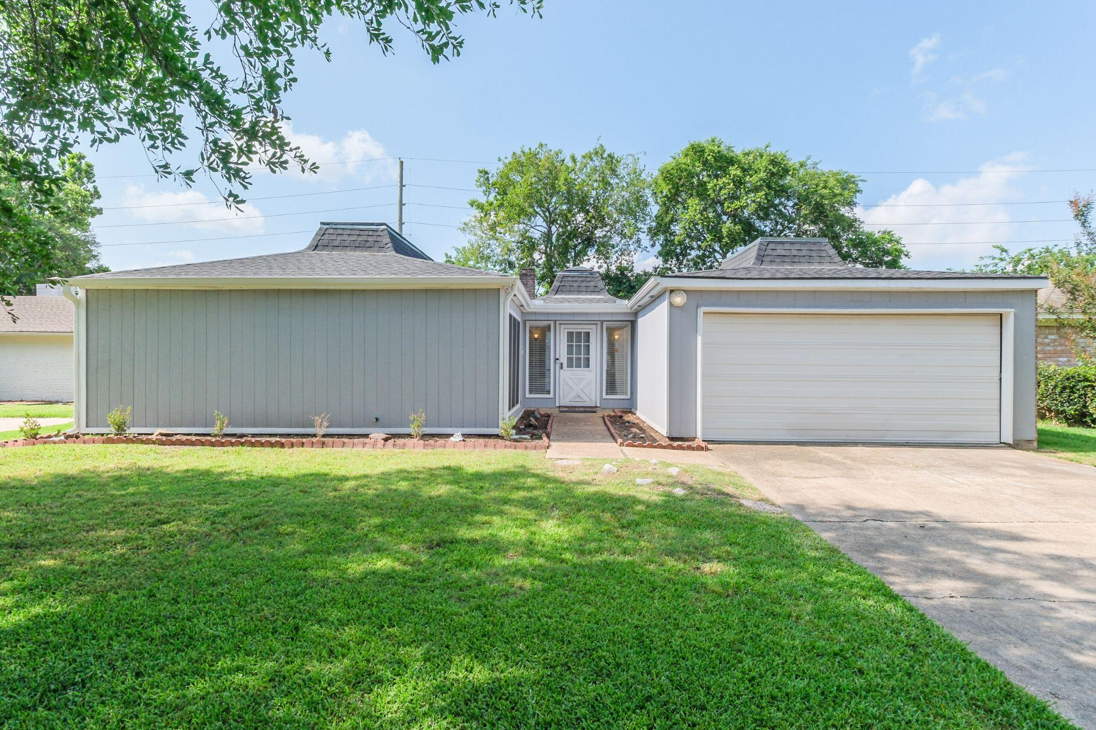

House Overview
—
Bedrooms | 3
Baths | 2 Full Baths
Square Feet | 1,882 per HCAD
Lot Size | 7,215 per HCAD
Year Built | 1971 per HCAD
Garage | 2 Car Attached
Neighborhood | Energy Corridor

OVERALL
- New water heater, 2024
- New roof, Nov. 2020
- New seamless gutters
- Added facia board all around exterior of house
- Added siding on patio
- Added new Luxury Vinyl Plank (LVP) flooring throughout home (minus baths and kitchen)
- Newer electrical outlets and light switches in most locations
- New breaker box on exterior of home
- Ring doorbell installed
- HVAC, 2011
- Located in the Briar Village neighborhood with community swimming pool and tennis courts
FRONT EXTERIOR
- Newer garage door opener
- 2 car attached garage; garage has multiple storage closets
- Double wide driveway
- Large front greenspace
BACK EXTERIOR
- Patio space with string lights, plenty of space for outdoor grilling and outdoor furniture
- Massive backyard green space
- Plenty of grass space for pets & children to play
- Fully fenced backyard
ENTRY
- Spacious formal foyer with room for entry furniture
- Door to attached garage
- Cost closet
- Large window with window blinds
FAMILY ROOM
- High ceiling with wooden beam
- Wood burning fireplace with painted brick surround
- Ceiling fan/light fixture
- Wood paneled wall
- LVP flooring
- Sliding door leads to patio/backyard
FORMAL LIVING/DINING ROOM
- Newer light fixture
- Ceiling fan
- Spacious room offers options for furniture placement
- Flexible room; could make an ideal family room, playroom, study
- Large window
- Light and bright room
KITCHEN
- Newer light fixture over kitchen sink
- Island with breakfast seating, storage and accent brick surround
- Electric cooktop on island
- Two ovens
- Lots of storage
- Two skylights; offering tons of natural light
- Open floor plan with breakfast area, family room and formals; ideal for entertaining
- Double basin stainless steel sink
- French door stainless steel refrigerator and freezer stays
- Stainless steel microwave
- Dishwasher
- Recently painted accent blue cabinetry
- Newer hardware
- Pantry closet
BREAKFAST AREA
- Opens to kitchen
- Newer light fixture
- Open shelving
- Large window with blinds

PRIMARY SUITE
- Spacious room
- Sliding door to patio
- Ceiling fan
- Newer LVP floor
PRIMARY BATHROOM
- Newer shower floor & shower wall tile
- Newer shower head/plumbing fixture
- Vanity knee space
- Granite countertop
- 2 decorative pendant lights
- Large walk-in closet
SECONDARY BEDROOM #1
- Closet
- Newer ceiling fan
- Newer door hardware
- Window with window blinds
SECONDARY BEDROOM #2
- Window with window blinds
- Newer ceiling fan
- Newer door hardware
- 2 closets
GUEST BATHROOM
- Vanity with granite countertop and 2 pendant light fixtures
- Newer toilet
- Newer flooring
- Linen closet
- Tub/shower combo with newer tile wall surround and new plumbing fixture
UTILITY CLOSET
- Located in hallway
- Washer and dryer stay
INCLUSIONS:
- String lights on patio
- Washer and dryer
- RING doorbell
- Kitchen refrigerator

