Improvements to 716 Penn Drive:
- Stair railings upgraded 2016
- Refrigerator 2016
- Led lighting throughout 2018
- All exterior lighting upgraded with light sensor automatic on/off 2018
- Landscape low voltage lighting system installed in 2018 500$, diagram below shows where wires are buried, the 2 front circuits follow the foundation and the walkway to the street, front right circuit makes a right turn to the base of the oak, back circuit goes in a straight line from the transformer to the first light, the system turns on/off automatically based on light levels, inside the box there is a bypass loop to change it to manual.
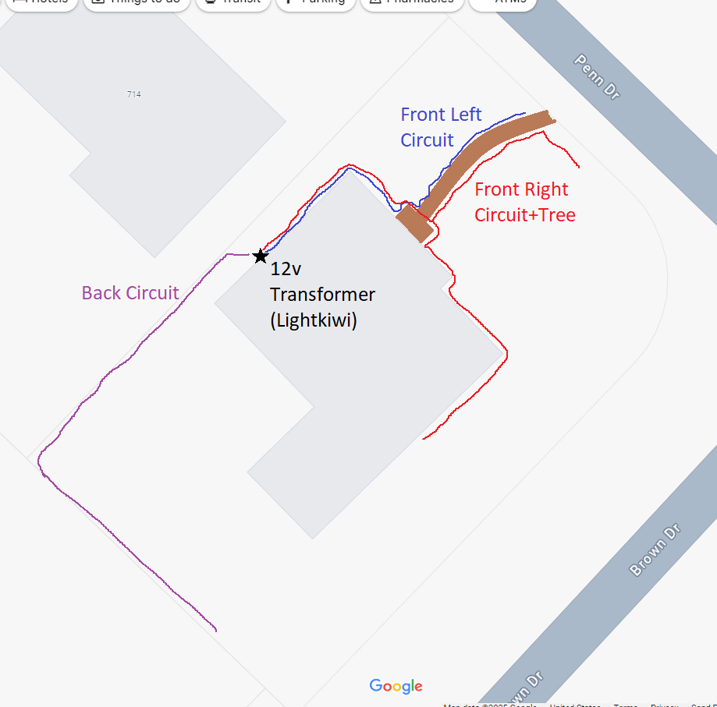

- 2019 22.500$
  - Upgraded Fireplaces quartz (Living room/Primary Bedroom), NOTE: the original brick has been left intact under the sheet rock 2019 (see pictures from before 2016)
  - Wainscoting trough living/dining/hall 2019
  - French doors installed on living room 2019
  - Laundry moved in to utility closet in family room (hookups still available at previous location, drain is plugged and behind sheetrock, dryer vent has been closed) 2019
  - Added door between office and staircase landing (NOTE: there is an extra door in the garage, this was only used temporarily and can be put back in to service, a connection between the office and the kitchen can be re-opened to hang the door, see where the base board is missing in the kitchen) 2019

- Lightning prevention system (600$ installed 2023), the 2 rods on the roof connect to a cable that runs next to the corner of the chimney, there is a 6 foot copper rod about 5 inches below the ground about 2 feet from the back of the chimney where it connects to.
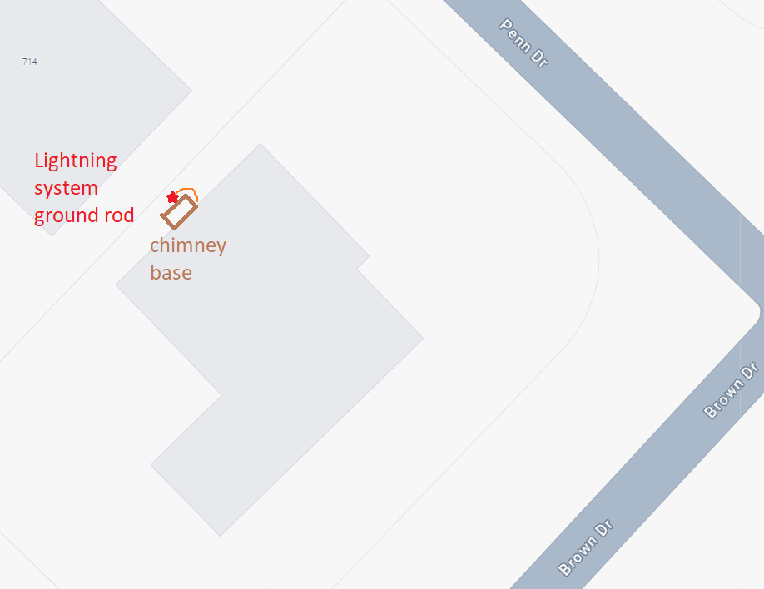

- Gourmet gas range with gas line installed in kitchen (220v socket still available behind range 2020 2250$)
- Dishwasher upgraded in Dec 2024 (1390$)+ 5 year protection plan
- Carpet replaced with high end laminate trough second floor and stairs 2023 (lifetime installation warranty see paper copy 10.000$)
- Attic ladder upgraded to aluminum in 2024
- New microwave with outside vent installed late 2024
- Ventilation fan installed in primary bath 2024
- New screens on back patio (2025) 700$
- Upgraded fiberglass double pane back doors “Steves & Sons” (towards patio and garage 2022) 3100$
- Garage door opener replaced in 2020 500$
- Fascia/soffit/gutters replaced when new roof was installed 2024
- Roof replaced in 2024; $24,432 (see file for warranty information)
- Attic insulation upgraded in 2024 as the roof was being replaced
- Front door refinished with poly resin 2023 400$
- Added 12x12 air return vent in large bedroom 2022
- HVAC system upgraded to a high efficiency inverter unit, 2023 16.247$ (still in warranty, see paper copy for warranty details, the system is currently maintained twice a year by the installation company: Weeks Service Company)
- Foundation repair with lifetime warranty performed in 2018, 9.470$

Remarks:
- Kitchen lamp ballast has been bypassed (only supports LED lights) the current lights have 4 temperature settings that can be adjusted with a switch on the tube itself
- The whole garage is GFI protected by the grey plug on the back wall, that will trip before the breaker does
- There are glass shelves available for the office built-in in the workshop
- Frames for screens for the bay window are in the garage
- The loop in the ceiling of the patio is meant to hold a hanging chair
- There are 2 220 volt outlets in the garage on the right of the garage door (this can support heavy machinery or a level 2 electric car charger)
- The house has AT&T Fiber (fiber in the house)
- In the garage there are several sheets of half inch plywood, as well as 2 bags of clips, these are cut to size to cover windows in case of severe weather
- The cabinet above the kitchen sink contains appliance manuals, warranties, and misc. items that are meant for the next owner.
- The gap between the drawers and the lazy Susan in the kitchen is intended for an appliance such as standalone ice machine or small form factor refrigerator/wine cabinet (there is an outlet)
- There are lights in the shed, the switch is located near the entrance top right
- The key box by the garage door has been reset to code 0000, pull from the top to open then move the tiny lever over the step to change the code
- The French door in the garage was previously used between the kitchen and the front room, the door jamb is still there behind the sheet rock and can be easily re-opened
- There is a fan in the workshop that plugs in, this helps ventilate the workshop.
- The main water valve is located opposite the water heater on the exterior wall, the water meter well is shared with the neighbor at 714 where the front yards meet.
- Highly recommend looking in to Energy Ogre for electric supply needs
- Highly recommend Stefano’s Pizzeria, don’t order online, rather call and ask if they have homemade mozzarella (this option is not available when ordering online), and the desserts are…well just try them.

