Exclusive Resident Amenities
Condo owners have private access to facilities reserved solely for their use:
- Private Common Areas: A residential lobby designed by Fendi Casa, a private resident-only lounge, card room, and game room.
- Health & Wellness: A private indoor lap pool and a state-of-the-art fitness center.
- Business Services: Private conference rooms, meeting spaces, and a dedicated business center.
- Transportation: 24/7 valet parking, assigned garage spaces with EV charging stations, and a rooftop helistop for quick access to Houston's airports.
Unit & Building Features
- Outdoor Living: Large private balconies, some featuring customized outdoor kitchens and personal plunge pools.
- Interior Design: Floor-to-ceiling windows with panoramic views of Buffalo Bayou Park and the downtown skyline, equipped with Thermador appliances and Pedini Italian cabinetry.
- Pet Benefits: Pet-friendly features include dog walking services (for hire) and pet washing stations.
- Location: Immediate pedestrian access to the 160-acre Buffalo Bayou Park and its extensive trails, easy access to downtown and I-45
Thompson Houston Hotel Services
Residents receive "all-inclusive resort" benefits from the on-site Thompson Hotel:
- Concierge & Dining: 24/7 dedicated concierge and room service, in-residence dining, and priority access to three on-site world-class restaurants, a poolside café, and casual coffee shop.
- Pool Deck: Access to a one-acre seventh-floor pool deck featuring private cabanas, a specialty bar, and a poolside cafe.
- Wellness: Use of the award-winning deluxe spa and sauna facilities.
- Home Services: Housekeeping, nightly turndown service, and dog walking or grooming arrangements.
Community & Social Activities
- Resident-only Events: The building features private resident-only lounges and party rooms that can be booked for private gatherings, conversation, and effortless evenings.
- Hotel Events: Residents have priority access to and can attend various events hosted at the Thompson Houston hotel, such as the inaugural Krewe of Porus Mardi Gras Ball event on Saturday, January 31, 2026.
- On-site Dining & Bars: The development includes several high-end restaurants and specialty bars, such as Toca Madera and Meduza Mediterrania, which serve as social hubs for dining out and meeting neighbors.
- Outdoor Relaxation: The one-acre seventh-floor pool deck with private cabanas and a specialty bar is a popular spot for relaxing and socializing with other residents and hotel guests.
Health & Wellness Activities
- Fitness: Residents can stay fit using the private indoor lap pool or the state-of-the-art gym within their building, in addition to access to the hotel's award-winning spa and fitness center for deluxe treatments.
- Outdoor Recreation: The residences are steps away from the 160-acre Buffalo Bayou Park, where residents commonly engage in activities like hiking and biking on the extensive trails, visiting the large dog park, and enjoying picnics or art installations.
- Water Activities: The proximity to the park also allows for outdoor activities on the bayou itself, such as canoeing and kayaking or participation in annual events like the Buffalo Bayou Partnership Regatta.
Cultural & Local Exploration
- Arts and Culture: The location in Houston's inner loop offers proximity to the Theater District, various museums, and art galleries, allowing residents to immerse themselves in the local art and cultural scene.
- Local Exploration: The area surrounding the residences encourages exploring unique boutiques, local markets, and breweries, offering ample opportunities to engage in a wide array of Houston activities.

The Residences at The Allen and the Thompson Houston Hotel offer several on-site, chef-driven restaurants and bars ranging from a casual cafe to upscale dining.
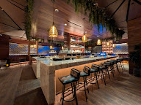
Toca Madera Houston


This modern Mexican steakhouse, located in The Pavilion at The Allen, features a vibrant atmosphere and menu with bold flavors, sustainable ingredients, and live-fire cooking elements.
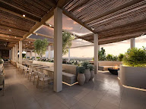
Mēdüzā

An Eastern Mediterranean concept from the same hospitality group as Toca Madera, located in the adjacent Pavilion.

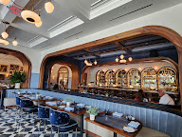
Chardon

A modern French brasserie and bistro that offers a fresh perspective on French cuisine using local ingredients and serves brunch, lunch, and dinner.

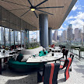
Sol7 Restaurant & Bar

Located on the seventh floor by the pool deck, this casual restaurant and bar provides a light-filled setting with global flavors and contemporary cuisine for breakfast, lunch, and dinner, along with cocktails and views of the Houston skyline.

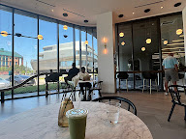
Maven

A ground-floor casual cafe that serves specialty coffee and light bites during the day and transitions to a cocktail atmosphere in the evening.

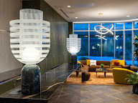
The Residences at The Allen

An upscale American supper club located within the hotel tower, featuring classic American cuisine, nightly live music, and a fine dining experience.
In-residence dining and room service are also available to residents through the Thompson Houston Hotel services.

